Analysis of Factors that Influence the Conditions of Bridges in California

Authors:
Swetha Sathishkumar
ssathis3@gmu.edu
George Mason University

Appala Dhanush Balireddy
abalired@gmu.edu
George Mason University

Manasa Rajagopal Madabushi
mmadabus@gmu.edu
George Mason University

Lavanya Nerale Ramesh
lneraler@gmu.edu
George Mason University

Syama Latha Seera
sseera2@gmu.edu
George Mason University

Team Number: 8

Instructor Information
Dr. Eddy Zhang, phd
AIT-614-002 Big Data Essentials
George Mason University

Word count: 3258

Submitted: 19 November 2024

ABSTRACT:
This study explores the factors influencing structural length and conditions of bridges in California using a rich dataset from the Long-Term Bridge Performance (LTBP) InfoBridge portal. Using data from the InfoBridge site, this study examines the variables affecting the lifespan and conditions of bridges in California. Bridge age, condition, material type, and traffic load are among the parameters included in the dataset, which consists of over 25,000 bridge records. In order to investigate trends in bridge deterioration, the project uses sophisticated analytical tools, utilizing Databricks for big data processing and PySpark for distributed data handling.
Machine learning methods like linear regression and logistic regression are used with Spark MLlib to analyze the factors that influence the conditions of the bridges. Additionally, relevant visualizations were created to gain actionable and meaningful insights into patterns and trends surrounding the bridges in California.
We were able to identify the cities with the most bridges and the top materials used to build bridges in California: many forms of concrete. Finally, using machine learning, we learned that the data fields in this dataset (Bridge Age, Number of Spans, etc.) do not influence the conditions of the bridges in California. The visualizations from the data analysis provide a data-driven method of allocating resources by highlighting high-risk bridges that need urgent maintenance. This study highlights the importance of big data in proactive infrastructure management by utilizing predictive analytics, opening the door for safer and more intelligent bridge maintenance techniques.
Key Words: Bridge Longevity, Maintenance Prioritization, PySpark, Databricks, Spark MLlib, Predictive Analytics.

INTRODUCTION
Bridges play a crucial role in our daily lives, connecting people, communities, and economies. However, maintaining bridges' strength and safety becomes increasingly difficult as they age and are subjected to growing pressures. This research explores the extensive dataset made available by the InfoBridge site, a platform developed by the Federal Highway Administration's Long-Term Bridge Performance (LTBP) initiative. The portal is a priceless tool for comprehending and enhancing bridge conditions since it provides comprehensive insights into bridge performance throughout the United States.
To identify patterns and trends that impact bridge security, reliability, and maintenance requirements, we are concentrating on examining bridge data unique to California. We investigate important variables like traffic loads, material types, and present conditions using advanced big data tools like Databricks and PySpark combined with machine learning models from Spark MLlib. Setting priorities for repairs and improving public safety will be made easier with these insights.
The scope of this project is to select a dataset from the InfoBridge portal and apply data analytics technologies and draw significant conclusions from it. We will explore trends and patterns which could impact bridge safety and conditions. Bridges are crucial to the public worldwide, and bridges are used for accessibility very, very frequently in the United States. It is used in interstate highways, local highways and even local roads. Therefore, it is crucial for us to understand the key functionalities of the bridges and any threats or safety concerns that they may pose to the public.
This project also offers practical experience with state-of-the-art technologies and real-world data as part of George Mason University's AIT-614-002 course. Beyond the technical know-how, it's an opportunity to make a significant contribution to the planning and upkeep of infrastructure, demonstrating how data can lead to safer bridges and more smart choices for all. As part of the AIT-614-002 course in George Mason University, we are analyzing this dataset for the final project. We hope to use NoSQL Databases, Big Data Engines and Big Data Platforms to analyze and draw conclusions from the dataset. Through the use of all these technologies, we hope you gain real-world experience in analyzing complex and relevant dataset, such as this one.
METHODS
The project's methodology involves analyzing bridge data from the InfoBridge dataset using machine learning techniques and big data tools. Data intake, preprocessing, descriptive analysis, predictive modeling, clustering, classification, and visualization were all steps in the process. Every stage was carefully planned to guarantee accurate evaluation and useful insights.
Preprocessing and Data Ingestion
The Databricks environment, being the main platform for data analysis and storage, received the dataset. Over 25,000 records represented the information, which included characteristics like Material Type, Bridge Age, Traffic Load, and Condition Rating. Following ingestion, missing data were addressed using the proper imputation techniques, and column names were standardized for consistency. For instance, category data, such as Main Span Material, was transformed into numerical formats to help in machine learning, and numerical columns that included missing values were filled in using median or mean values. The dataset was ensured to be clean and prepared for analysis by these preparation procedures.
Descriptive Analytics
To get an understanding of the dataset, descriptive statistics were generated. For important variables like Bridge Age, Condition Rating, and Average Daily Traffic, metrics like mean, median, mode, and standard deviation were calculated. By focusing patterns and distributions across different aspects, these metrics gave a basic picture of the dataset. To further investigate patterns in the data, visualizations such as scatter plots, bar graphs, and histograms were made. To find any geographical variations in bridge conditions, for example, regional distributions of traffic loads and bridge materials were examined.
Predictive Analytics
Spark MLlib was used to use predictive analytics approaches in order to identify future trends. In order to predict Average Daily Traffic, a linear regression model was created using characteristics such as Deck Area, Roadway Width, and Bridge Age. This model highlights the ways in which these factors affected traffic patterns. A logistic regression model was also used to assess and predict the conditions of the bridges.This model was employed to predict bridge conditions based on features such as Bridge Age and Main Span Materials.
Visualization of Data
In order to properly communicate the project's findings, visualizations were essential. To show important trends, we made interactive plots and charts using Databricks notebooks. For instance, geographical maps demonstrated the location of high-risk bridges throughout California, while scatter plots demonstrated the correlation between Bridge Age and Condition Rating. To spot trends and provide clear, visual proof for the analytical conclusions, these visualizations were important.
Big Data Architecture
The Databricks platform, which had strong processing and storage capabilities for managing big datasets, was used to build the complete workflow. For distributed data processing, PySpark was used, guaranteeing scalability and effectiveness while managing more than 25,000 records. Effective training and assessment of predictive models were made possible by the smooth integration of machine learning models created using Spark MLlib into the Databricks environment. This architecture made the study thorough and actionable by enabling rapid iteration and real-time insights.
Experimental Insights
Key conclusions from the investigation included the fact that concrete is frequently used as the main material for bridges in California and that there aren't any significant relationships between structural length and spans or between certain features and bridge conditions. These revelations highlight the necessity of including more variables, such as the surrounding environment, in subsequent investigations.
This approach opens the door for more efficient bridge management and repair plans by demonstrating the potential of big data and machine learning in solving challenging infrastructure problems.

RELATED WORK

The goal of The Development of a Life-Cycle Cost Analysis Tool for Bridges was to develop a tool that would use previous performance data to track and predict maintenance costs for bridges. The study created a methodology which was designed especially for Iowa bridges that uses survival analysis and deterioration models to predict a bridge's working life. The focus was on applying life-cycle cost analysis (LCCA) to make investment decisions and estimating future maintenance needs by combining past inspection data.[1]

Heavy truckloads have been linked to the faster deterioration of bridge decks, according to the Correlation of Bridge Deck Deterioration with Truckload Spectra study. The study created models to relate truckload spectra to bridge deck service life using Weigh-in-Motion (WIM) and National Bridge Inventory (NBI) data. This study demonstrated how axle loads, especially those from overweight trucks, significantly shorten bridge deck lifespans. [2]

On the other hand, our project will combine degradation modeling with current big data tools like Databricks and PySpark to analyze massive datasets more quickly and provide accurate and scalable bridge performance predictions. By incorporating machine learning with Spark MLlib, prediction precision is improved and a more thorough examination of California bridge lifespan is provided.

SELECTED DATASET

The original source data from the InfoBridge portal contains over 200,000 records. Since such large data requires faster systems, we filtered it to just the Bridges in the State of California. Therefore, our final dataset for this project contains just over 25,000 records. The selected dataset also has all 20 features. Some of the columns that are thinking about selecting for data analysis are: County Name, Main Span Material, Main Span Design, Year Built, Bridge Age, Average Daily Traffic and Bridge Condition.

We believe these are important features to study through our data analysis because these factors have the potential to influence the longevity and performance of the bridges. Factors like Main Span Material and Design can help us identify which combinations yield the best durability of the bridges. Additionally, factors like Average Daily Traffic and Bridge Condition will help us understand the impact of daily usage on bridge conditions which will provide insights for future maintenance and further constructions.

DEVELOPMENT TECHNOLOGIES/PLATFORMS

For this project, we will utilize Databricks as our primary big data platform. It will provide us with powerful capabilities for data processing and analytics. Additionally, we will store our data in Databricks DBFS, a NoSQL database that allows for efficient management and access to large datasets. Finally, we will employ PySpark for distributed data processing and Spark MLlib for implementing machine learning algorithms. PySpark and Spark MLlib will help us perform data analysis and machine learning implementation in our project.

Databricks acts as the main big data platform for data processing and storage in the proposed architecture. The bridge dataset, which has been filtered for California, is kept in a NoSQL database called Databricks DBFS, which offers scalable storage for the large dataset. PySpark will be used to handle and manipulate the data in a distributed manner.

In order to do predictive analysis and find patterns in bridge degradation and maintenance requirements, the system incorporates machine learning models that are constructed using Spark MLlib. For smooth workflow execution, the complete procedure will be integrated on Databricks. In summary, we believe to effectively analyze the large volume of bridge performance data and derive meaningful insights by using the technologies mentioned above.

EXPERIMENTAL RESULTS

Initially, we used PySpark to clean, pre-process, summarize and create visuals of the data.

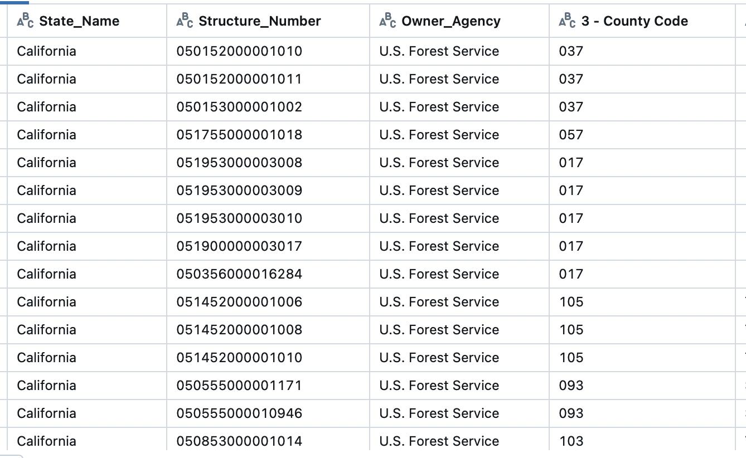
Figure 1: Preview of the cleaned and preprocessed dataset loaded in Databricks

Next, we identified the top 20 cities in California with the most number of bridges (Figure 2). The top 5 cities were Los Angeles, San Diego, San Jose, Sacramento City and Fresno. Los Angeles is one of the most popular cities in the world. Therefore, it is not surprising that it has the most number of bridges to improve accessibility to all the residents and tourists.

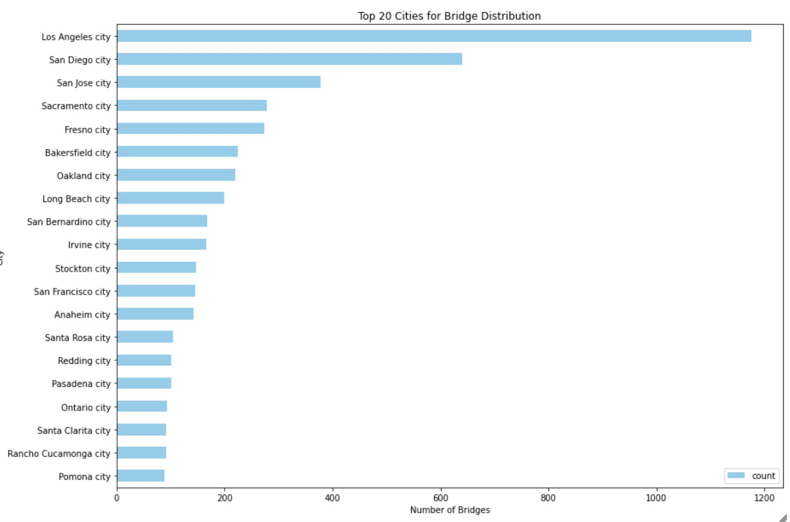
Figure 2: Top 20 cities in California with the most number of bridges

Next, we attempted to identify the most popular materials used to construct the bridges in top 5 of the cities in California (Figure 3). We identified that most of the bridges uses concrete (Plain Concrete, Continuous Concrete, Pre-Stressed Concrete, etc.). This makes sense because concrete is strong and offers good protection against earthquakes, which is common in California. Using concrete is also best for long-spanning bridges which is also commonly found all throughout California. Furthermore, I noticed that continuous concrete and prestressed concrete are two most commonly used materials in bridges, except for LA which uses Plain Concrete for many of the bridges. LA was developed in the 20th century, and during this time concrete technologies were still evolving. So, it makes sense that LA has many bridges made of plain concrete.

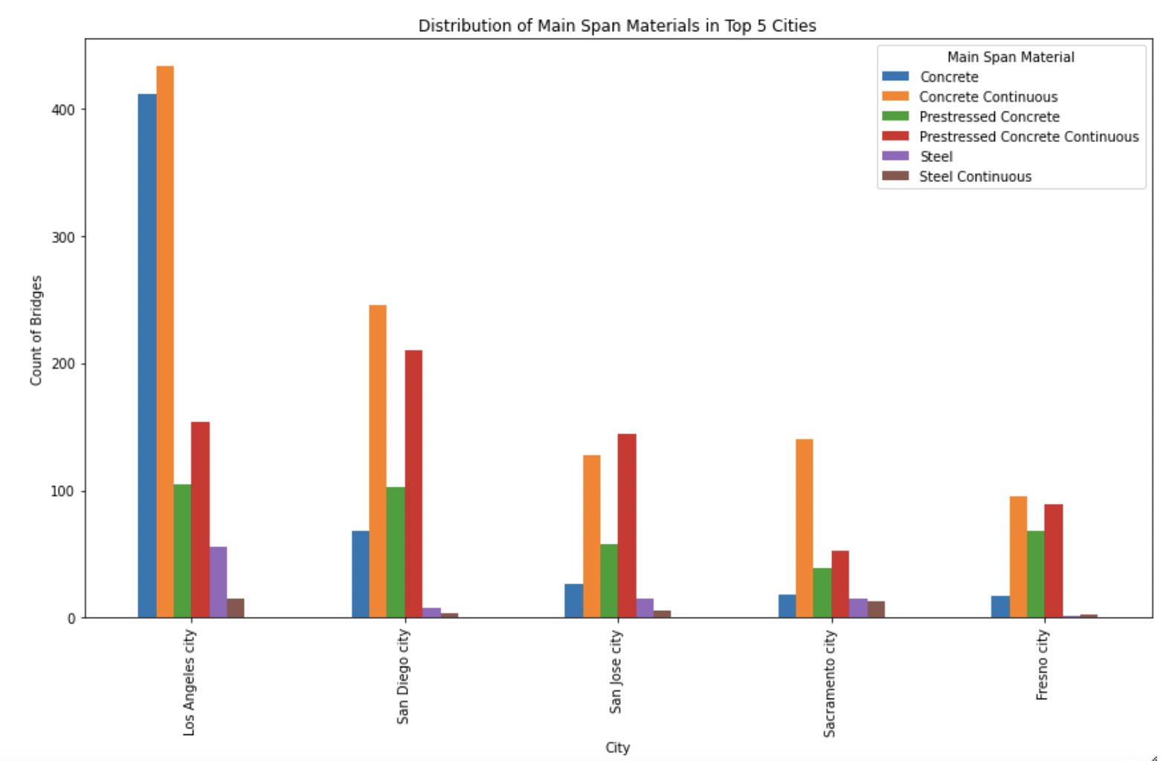
Figure 3: Main span materials used in bridges in California’s top 5 cities

Next, we used regression to predict the structural length of the bridges based on the number of spans. The dataset was cleaned and split into training and test sets. Then, we displayed the actual values and the predicted values in a graph (Figure 4). Based on the graph, all the data points formed a square rather than spreading across the linear regression line. This shows that there is no strong correlation between the structural length and the number of spans.
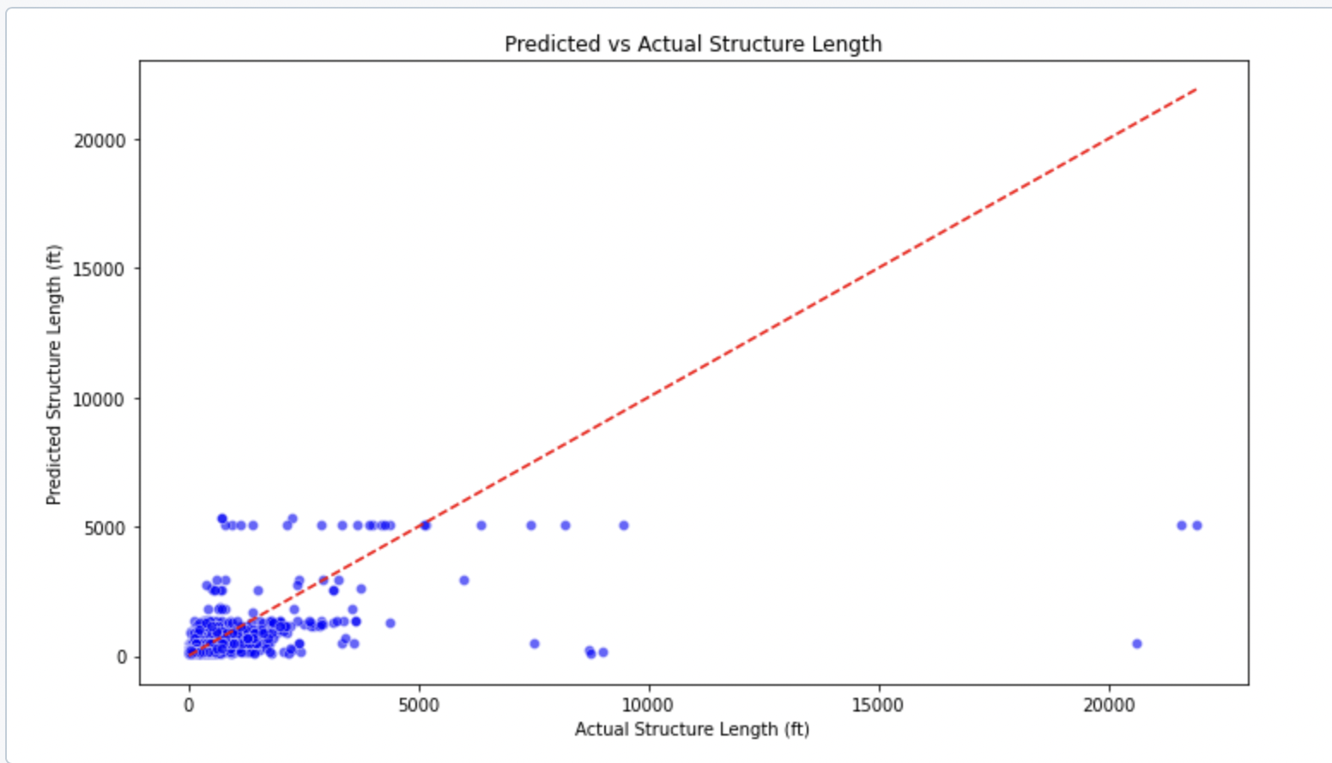
Figure 4: Results of the Linear Regression Model

Finally, we tried to find the factors that influenced bridge conditions in California. First, we selected the following features: Main Span Materials, Main Span Design and Number of Spans. We used logistic regression to generate the model. Figure 5 shows the results from the model.
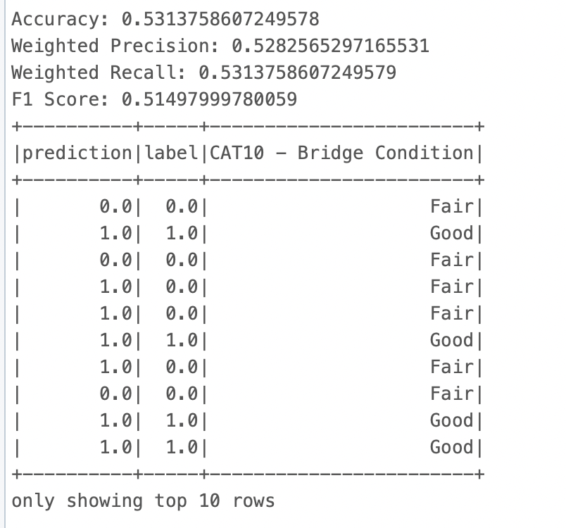
Figure 5: Results from Logistic Regression Model

As you can see in Figure 5, the model is very moderate and not at all effective. So, we selected different features (Main Span Materials and Bridge Age). After creating another logistic regression model, we still got the same results (Figure 6). The model is very moderate and not effective in determining the conditions of the bridges in California.

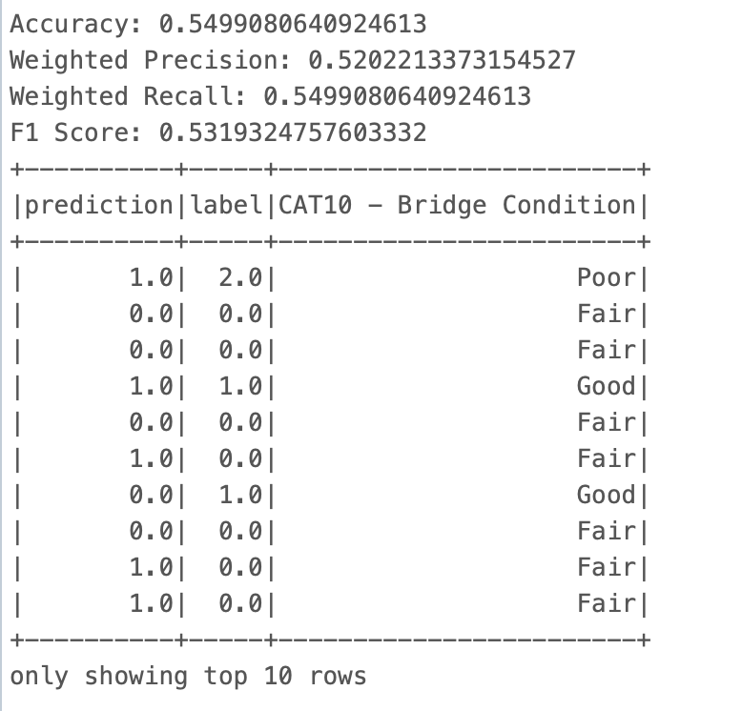
Figure 6: Results from refined Logistic Regression Model

DISCUSSION

Through this research, we learned that Los Angeles, San Diego, San Jose, Sacramento City and Fresno are the cities with the top 5 most number of bridges in California. We also learned that over 75% of the bridges in these cities use some form of concrete as the main material to construct the bridge. This makes sense because concrete is strong and offers good protection against earthquakes, which is common in California. Using concrete is also best for long-spanning bridges which is also commonly found all throughout California.

Additionally, we learned that the structure length of the bridge is not influenced by the number of spans. There is no correlation between these two variables; we determined this from the linear regression model in Figure 4. Additionally, we used logistic regression to identify factors that influenced bridge conditions. We ran two different models: Figure 5 and Figure 6. However, the models were very moderate and did not effectively predict the bridge conditions. This shows that features like Age, Span Materials, Span Design & Number of Spans do not affect the bridge conditions like we thought they would. This makes us wonder which factors truly affect the condition of the bridges, and maybe these are factors that are not included in the dataset.

In the future, we could look into some advanced techniques like K-Means Clustering, Classification, Neural Networks, etc. to gain insights from the bridges. We can also expand it to other states; so far we only analyzed the state of California. We would like to analyze how bridge conditions, bridge age, number of spans and materials differ from one state to another. It would be very interesting to compare trends and patterns found among bridges in different states in the United States.

Overall, big data platforms are way more capable of processing volumes of information far more efficiently and accurately to make predictions using machine learning models. Using Azure Databricks for this project has been very convenient for us. We are able to perform everything in the cloud without the need to download any additional software or use of PC storage. Furthermore, using PySpark and Spark MLlib has been very simple, but effective. We were able to gain some significant results from this dataset in a short amount of time in a simple and quick manner. These technologies have streamlined this project significantly.

Therefore, this research tries to incorporate structural, traffic, and environmental factors to establish a comprehensive view of the conditions of the bridges, which will provide insight into the decision-making processes necessary for infrastructure maintenance. The ultimate goal of this study is to enable transportation authorities to manage the maintenance of bridges proactively for their long-term safety and reliability.

CONCLUSION

In conclusion, this research successfully used machine learning and big data analytics to examine the variables affecting the conditions of California bridges. We gained some valuable insights on bridges in some of the major cities in California. Linear and logistic regression models were used to provide useful information on bridge conditions, which will help transportation authorities set maintenance priorities. This study demonstrates how predictive analytics may be used in infrastructure design to improve public safety and allocate resources optimally for long-term bridge reliability in a scalable and data-driven manner.
We learned to clean and analyze a sizable dataset using technologies like Databricks, PySpark, and Spark MLlib, revealing important trends and patterns pertaining to bridge conditions, materials, length, etc. We gained hands-on experience on how to use cutting-edge industry technologies in the field of Big Data Analytics. We learned a lot through this project, and we hope to work on projects similar to this during our time at George Mason and in our future careers.

ACKNOWLEDGEMENTS

We would like to sincerely thank Dr. Eddy Zhang, whose advice and knowledge greatly influenced this effort. We appreciate George Mason University and the instructors of AIT-614-002 for making these tools and learning opportunities available. We also thank the developers of the InfoBridge portal for providing the extensive dataset that served as the basis for our research. We thank Swetha Sathishkumar, Appala Dhanush Balireddy, Manasa Rajagopal Madabushi, Lavanya Nerale Ramesh, and Syama Latha Seera for their teamwork and dedication, which were essential to the successful completion of this project.

AUTHOR CONTRIBUTIONS

The project team collaboratively worked on various tasks to ensure the successful completion of the project. Below are the contributions of each team member:

- Swetha Sathishkumar: Played a key role in data cleaning, processing and creating machine learning models. She contributed significantly to the data analysis process using PySpark and creating models and visuals using ML models. Additionally, she also contributed to most of the Project Proposal and significant portions (experimental results section, conclusion, system overview, timelines, etc.) of the final paper and the final presentation.

- Appala Dhanush Balireddy: Took charge of implementing machine learning models alongside Manasa and Swetha. Additionally, he contributed to the preparation of the project presentation.

- Manasa Rajagopal Madabushi: Focused on testing the system and the implementation of machine learning models. She also contributed to the presentation sections on the selected dataset, system design, and experimental results.

- Lavanya Nerale Ramesh: Led the setup of the Databricks environment and contributed to implementing machine learning models. She prepared the presentation's cover, introduction, and system design sections, ensuring a well-organized delivery.

- Syama Latha Seera: Led the setup of the Databricks environment and was instrumental in data cleaning and preprocessing. She also contributed significantly to data analysis using PySpark, providing critical insights for the project's findings. She also contributed to the final paper.

The collaborative efforts of all team members ensured the development of a comprehensive working system, a detailed project report, and an engaging presentation. Each member's dedication and teamwork were crucial in achieving the project's objectives.

REFERENCES

[1] Yang, C., Lou, P., Nassif, H., & States., U. (2024, May). Correlation of Bridge Deck Deterioration with Truckload Spectra Based on NBI Condition Rating and Weigh-In-Motion Data. Bts.gov; United States. Department of Transportation. Federal Highway Administration. Office of Research, Development, and Technology. https://rosap.ntl.bts.gov/view/dot/74540 Accessed 21 Oct. 2024.

[2] Alipour, A., Shafei, B., Mock, A., Prajapat, K., & State, I. (2020, June). Development of a Life-Cycle Cost Analysis Tool for Improved Maintenance and Management of Bridges. Bts.gov; Iowa State University. Institute for Transportation. https://rosap.ntl.bts.gov/view/dot/55485 Accessed 21 Oct. 2024.

[3] Data - LTBP InfoBridge. (2020). Dot.gov. https://infobridge.fhwa.dot.gov/Data/SelectedBridges Accessed 21 Oct. 2024.

‌

